Q.1 Dancing Girl- Mohanjadaro

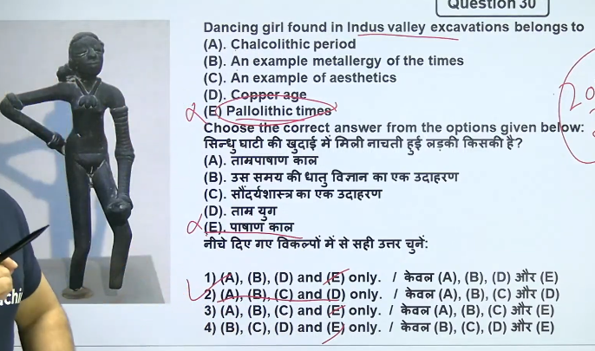

The "[Dancing Girl](https://www.google.com/search?q=Dancing+Girl&oq=indus+valley+civilization++dancing+girl&gs_lcrp=EgZjaHJvbWUqBwgAEAAYgAQyBwgAEAAYgAQyBwgBEAAYgAQyCAgCEAAYFhgeMggIAxAAGBYYHjIICAQQABgWGB4yCAgFEAAYFhgeMggIBhAAGBYYHjIICAcQABgWGB4yCAgIEAAYFhgeMggICRAAGBYYHtIBCTk3ODJqMGoxNagCCLACAfEFg-yu-U_5A_DxBYPsrvlP-QPw&sourceid=chrome&ie=UTF-8&ved=2ahUKEwi_rI_oje2SAxX84DgGHTInI8gQgK4QegYIAQgAEAM)" is a famous 10.5 cm tall bronze figurine from the Indus Valley Civilization (circa 2500 BCE), discovered in Mohenjo-daro in 1926. Created using the lost-wax casting method, this iconic, slender statue depicts a nude young girl in a confident, stylized pose with bangles on her arms, currently housed in the National Museum, New Delhi.

The [Indus Valley Civilization dancing girl sculpture](https://www.google.com/search?q=Indus+Valley+Civilization+dancing+girl+sculpture&sca_esv=e376e5018d0e0b4b&sxsrf=ANbL-n7uwGWErAtQGk4ntntDom3a8N79mQ%3A1771763616967&ei=oPeaab_cOvzB4-EPss6MwQw&biw=1366&bih=641&oq=indus+valley+civilization+dancing+girl+size+in+inc&gs_lp=Egxnd3Mtd2l6LXNlcnAiMmluZHVzIHZhbGxleSBjaXZpbGl6YXRpb24gZGFuY2luZyBnaXJsIHNpemUgaW4gaW5jKgIIADIFECEYoAFI37YDULAEWPyqA3ACeAGQAQCYAdABoAHjEKoBBjAuMTAuMrgBA8gBAPgBAZgCDKAClQ_CAgoQABiwAxjWBBhHwgINEAAYgAQYsAMYQxiKBcICCxAAGIAEGJECGIoFwgIGEAAYFhgewgIFEAAYgATCAgUQABjvBcICCBAAGIAEGKIEwgIFECEYnwWYAwCIBgGQBgqSBwUyLjguMqAHlziyBwUwLjguMrgH-A7CBwUyLTUuN8gHdYAIAA&sclient=gws-wiz-serp&ved=2ahUKEwjRrtXMju2SAxVL3zgGHav0G3MQgK4QegQIARAD) is approximately **4.1 to 4.25 inches** (10.5—11cm ) tall. This famous bronze statuette, discovered in Mohenjo-daro, measures roughly 10.5 cm in height, 5 cm in width, and 2.5 cm in depth.

**Key Details of the Dancing Girl**

* **Location of Discovery:** Mohenjo-daro, Sindh (present-day Pakistan) in 1926-27.
* **Current Location:** National Museum, New Delhi.
* **Material & Technique:** Bronze, created using the "[lost-wax casting](https://www.google.com/search?q=lost-wax+casting&oq=indus+valley+civilization++dancing+girl&gs_lcrp=EgZjaHJvbWUqBwgAEAAYgAQyBwgAEAAYgAQyBwgBEAAYgAQyCAgCEAAYFhgeMggIAxAAGBYYHjIICAQQABgWGB4yCAgFEAAYFhgeMggIBhAAGBYYHjIICAcQABgWGB4yCAgIEAAYFhgeMggICRAAGBYYHtIBCTk3ODJqMGoxNagCCLACAfEFg-yu-U_5A_DxBYPsrvlP-QPw&sourceid=chrome&ie=UTF-8&ved=2ahUKEwi_rI_oje2SAxX84DgGHTInI8gQgK4QegYIAQgAEAw)" method.
* **Dimensions:**

Approximately 10.5 x5x2.5 cm.

* **Appearance:** The figure is depicted in a naturalistic pose with a slightly tilted head, right hand on her hip, and left hand resting on her thigh. She wears a necklace and numerous bangles—24 or 25 on the left arm and 4 on the right.
* **Significance:** It represents the high level of metallurgical skill and artistic achievement of the Harappan civilization.
* **Interpretations:** While named the "Dancing Girl," some scholars suggest the pose could represent a woman in a defiant stance or a, "warrior," rather than a dancer.

The figurine is celebrated for its, "lively pertness," and is often considered a symbol of the artistic spirit of the Indus Valley Civilization.

Q.2

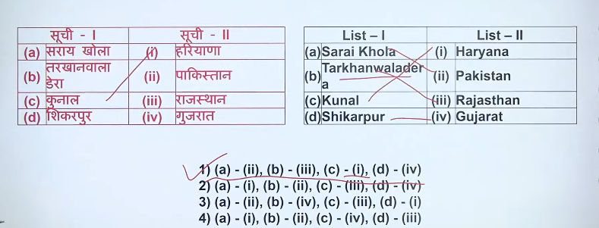

Q.3 3 based town classification - dholavira

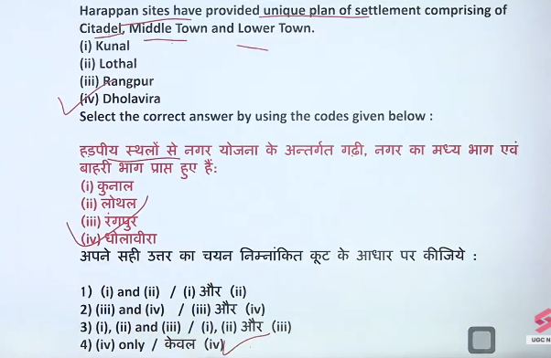

• Located in **Gujarat (Rann of Kutch)** on **Khadir island**.

• Had a **unique three-part town plan** — Citadel, Middle Town, Lower Town.

• Famous for its **advanced water management system** (reservoirs, channels).

• Discovery of a **large Harappan signboard** with Indus script.

• Built mainly with **stone** (rare among Harappan sites).

1. **Dholavira Gujarat में है**, Rann of Kutch के पास एक टापू (island) पर।
2. यहाँ **पानी जमा करने का बहुत अच्छा system** था (तालाब और जलाशय)।
3. शहर **तीन हिस्सों में बँटा था** — राजा का भाग, शहर का भाग, आम लोगों का भाग।
4. यहाँ **पत्थर से बने घर और दीवारें** मिली हैं (जबकि बाकी जगह ईंटें मिलती हैं)।

**Dholavira = Gujarat + Big city + Water system + Three parts + Stone buildings**

Only **one** major Harappan site, **Dholavira**, is widely recognized to have a town planning divided into three distinct parts.

Testbook +2

Key details about this division:

* **Location:** Situated on Khadir Beyt in the Rann of Kutch, Gujarat, India.
* **Three Parts:** The city was divided into a **Citadel** (acropolis), a **Middle Town**, and a **Lower Town**.
* **Unique Structure:** Unlike most Harappan cities (like Mohenjo-daro and Harappa) which were divided into two parts—a citadel and a lower town—Dholavira featured three, with each section surrounded by massive stone fortifications.
* **Additional Features:** It is also noted for its advanced water management system, including large reservoirs.

Testbook +8

While other sites, such as Kalibangan, had multiple fortified areas, Dholavira is the only one documented with the distinct tripartite (three-part) division.

[Rakhigarhi](https://www.google.com/search?q=Rakhigarhi&biw=1366&bih=641&sca_esv=e376e5018d0e0b4b&sxsrf=ANbL-n50GuNn_gBtPA7z4EWuozXaLAUgMw%3A1771764836254&ei=ZPyaad6ZD72SseMP5YCE8Q4&oq=mohanendjadro+or+rakhigari+which+&gs_lp=Egxnd3Mtd2l6LXNlcnAiIW1vaGFuZW5kamFkcm8gb3IgcmFraGlnYXJpIHdoaWNoICoCCAAyBxAAGIAEGA0yCxAAGIAEGIYDGIoFMgsQABiABBiGAxiKBTIFEAAY7wUyBRAAGO8FSPxzUPcMWJppcAh4AZABAJgBygGgAa0yqgEGMC4zNi4xuAEDyAEA-&sclient=gws-wiz-serp&ved=2ahUKEwjE74i4ku2SAxVjd2wGHW3NN6QQgK4QegYIAQgAEAY) is now considered the largest Harappan site, exceeding the size of [Mohenjo-daro](https://www.google.com/search?q=Mohenjo-daro&biw=1366&bih=641&sca_esv=e376e5018d0e0b4b&sxsrf=ANbL-n50GuNn_gBtPA7z4EWuozXaLAUgMw%3A1771764836254&ei=ZPyaad6ZD72SseMP5YCE8Q4&oq=mohanendjadro+or+rakhigari+which+&gs_lp=Egxnd3Mtd2l6LXNlcnAiIW1vaGFuZW5kamFkcm8gb3IgcmFraGlnYXJpIHdoaWNoICoCCAAyBxAAGIAEGA0yCxAAGIAEGIYDGIoFMgsQABiABBiGAxiKBTIFEAAY7wUyBRAAGO8FSPxzUPcMWJppcAh4AZABAJgBygGgAa0yqgEGMC4zNi4xuAEDyAEA-&sclient=gws-wiz-serp&ved=2ahUKEwjE74i4ku2SAxVjd2wGHW3NN6QQgK4QegYIAQgAEAc). Recent excavations have revealed that Rakhigarhi, located in Haryana, India, covers over 350 to 550 hectares across 11 mounds, while Mohenjo-daro in Pakistan is estimated to be around 300 hectares.

* **Rakhigarhi:** Considered the largest city of the Indus Valley Civilization, with evidence of early, mature, and late phases, and spanning 11 mounds.
* **Mohenjo-daro:** Long recognized as one of the largest and most developed urban centers of the civilization.
* **Significance:**

 While Mohenjo-daro was formerly considered the biggest, the sprawling size of the Rakhigarhi site makes it the largest known, as corroborated by archaeologists like Dr. Vasant Shinde.

Both sites are significant urban centers, but in terms of total area, Rakhigarhi has proven to be larger.

### 🏛️ Dholavira के Features

1. **तीन भागों में बसा शहर**
   * Citadel (ऊँचा/शासक भाग)
   * Middle Town
   * Lower Town
2. **पानी का बेहतरीन प्रबंधन (Water Management)**
   * बड़े-बड़े जलाशय (reservoirs)
   * बारिश का पानी जमा करने की व्यवस्था
3. **पत्थर का उपयोग**
   * घर, दीवारें और संरचनाएँ **stone से बनी** (Harappan sites में rare)
4. **मजबूत किलेबंदी (Fortification)**
   * ऊँची और मजबूत दीवारें
   * सुरक्षा पर विशेष ध्यान
5. **Indus Script का बड़ा साइनबोर्ड**
   * अक्षरों वाला बोर्ड मिला
   * लिखित संचार का प्रमाण
6. **सुनियोजित सड़कें और इमारतें**
   * Town planning बहुत व्यवस्थित
   * सीधी सड़कें, तय माप

### 🧠 One-line याद रखने की ट्रिक:

**Dholavira = Three parts + Water system + Stone buildings + Strong walls + Signboard**

Q.4

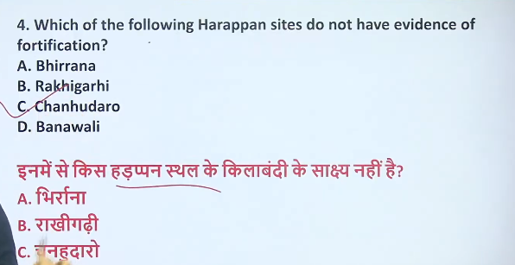

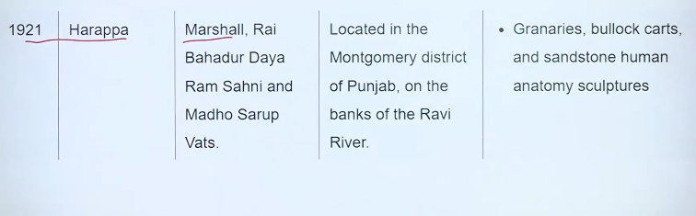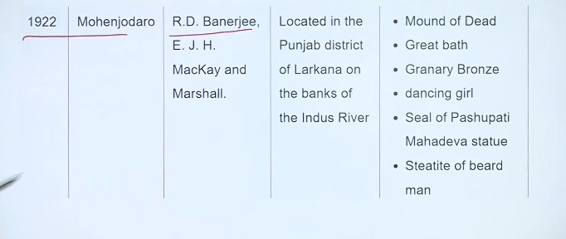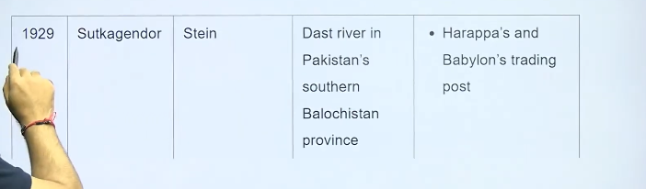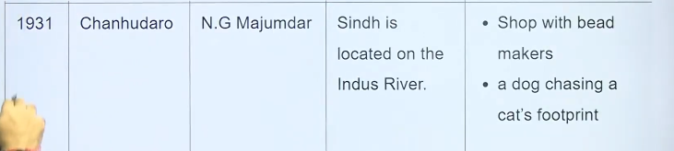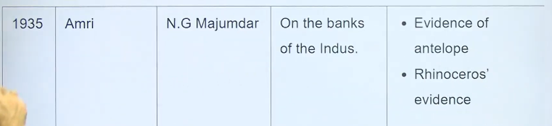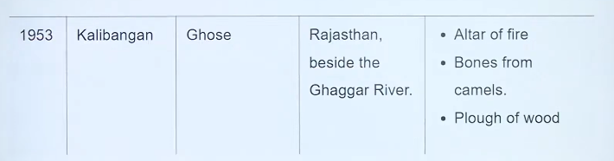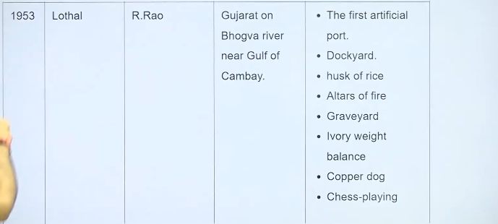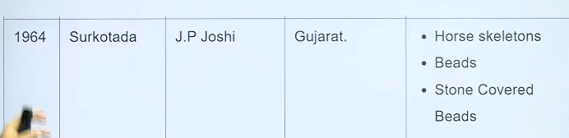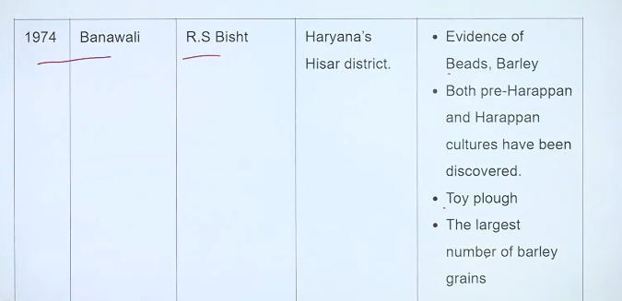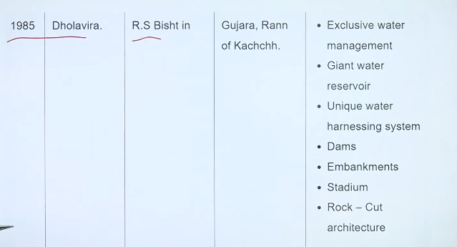

Q.5

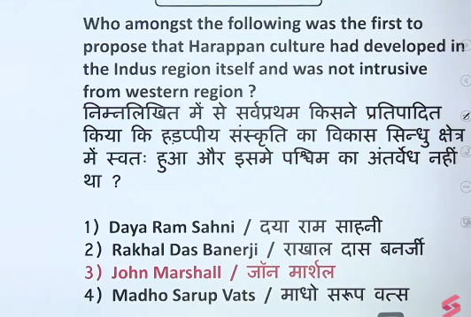

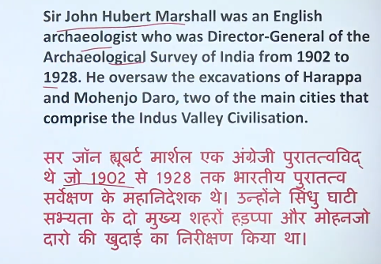

Q.6

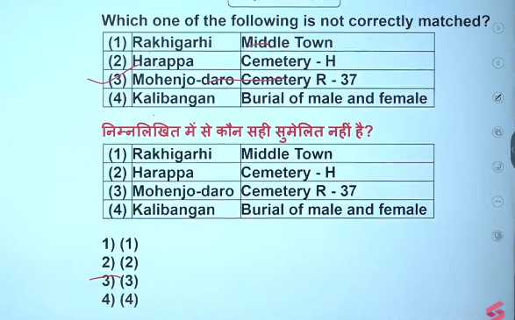

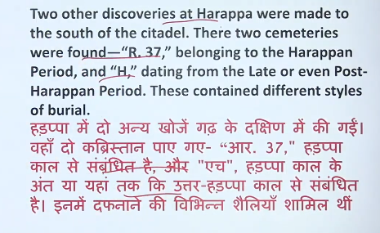

Q.7

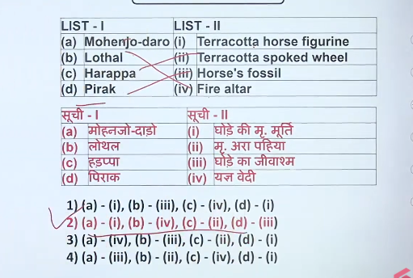

Q.8

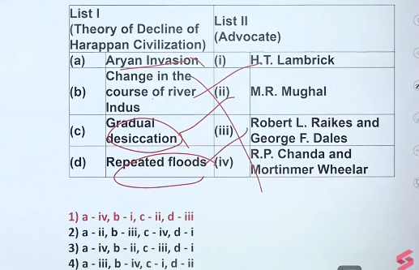

Q.9

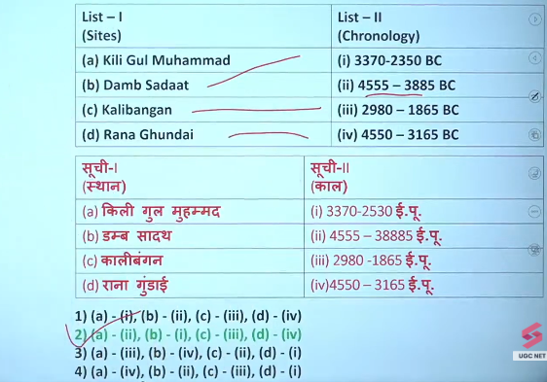

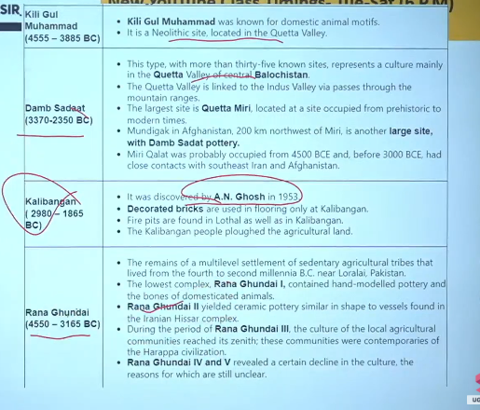

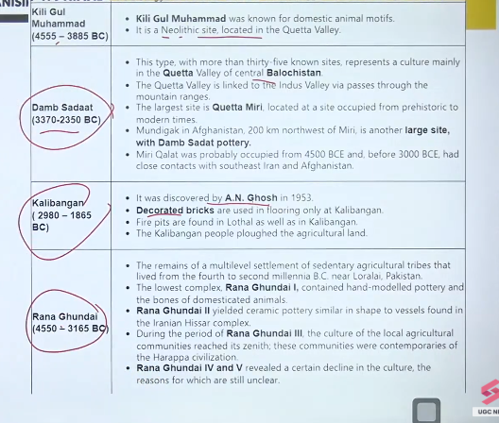

Q.10

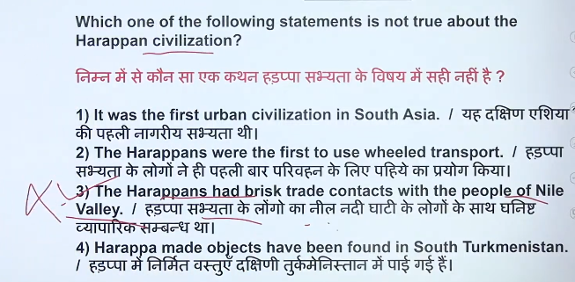

Q.11

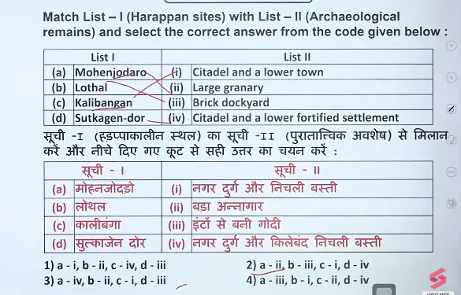

Q.12

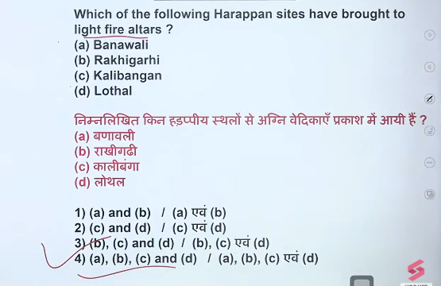

Q.13

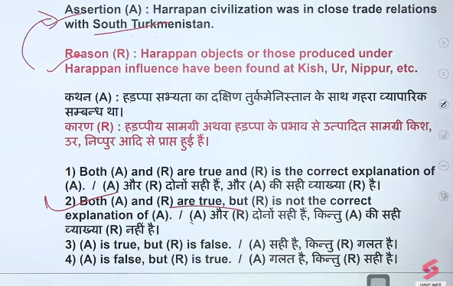

Q.14

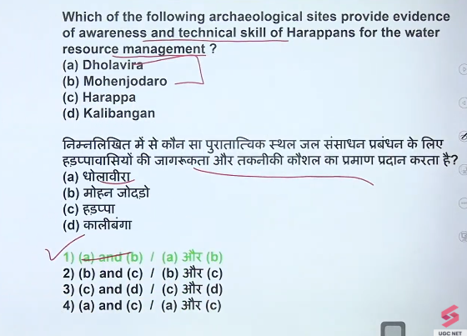

Q.15

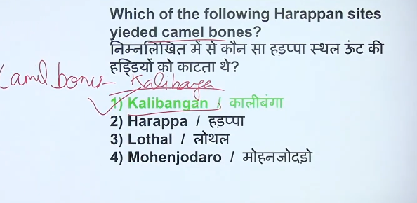

Q.16

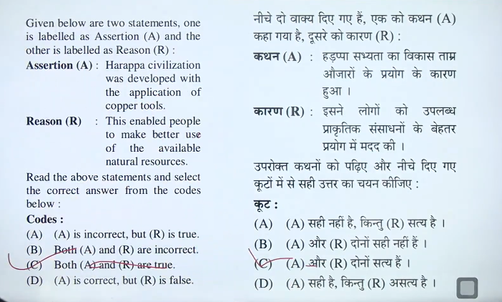

Q.17

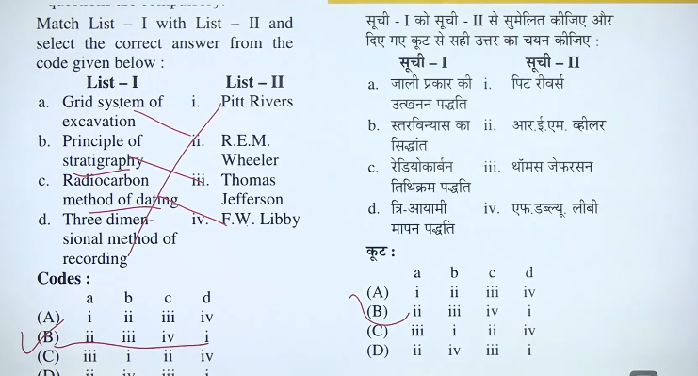

Q.18

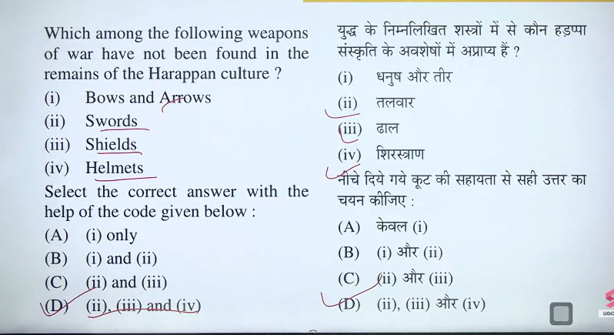

Q.19

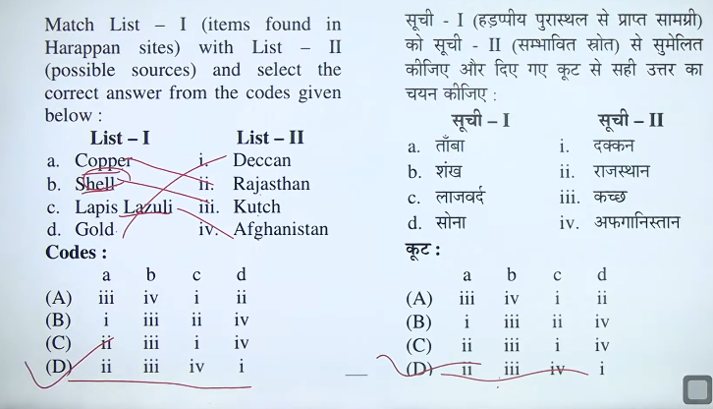

Q.20

